POLY PROPYLENE CARTRIDGE FILTER HOUSING

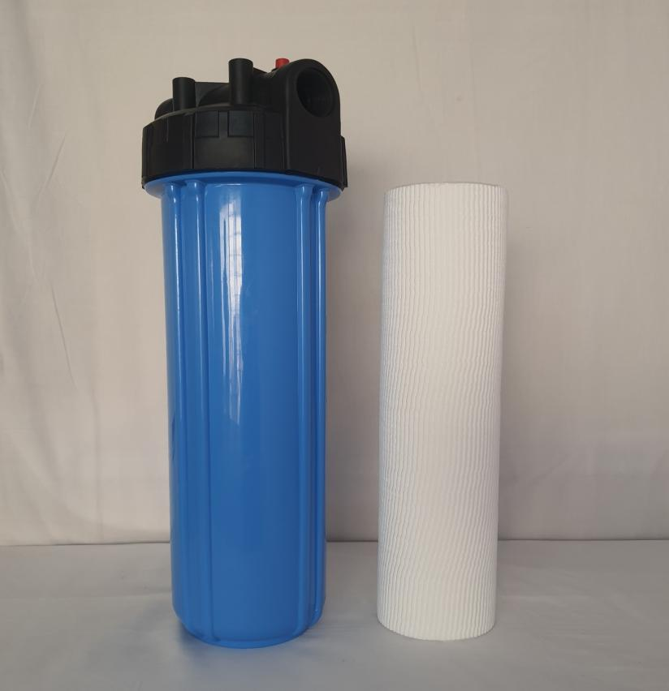

INTRODUCTION:

Polypropylene filter Housings are generally used in corrosive/saline liquid processing. Most of the water and waste water treatment plants and continues process industries. It is highly economical in price, light weight, durable and compact design. Considering the varied needs and applications of the end users, our products are customized to fulfil the application criteria.

FEATURES & BENEFITS:

* Compact Construction
* Filtration Rating upto 200 micron
* Easy to handle and maintain
* Can accommodate Cartridges

**TECHNICAL SPECIFICATION:**

|  |  |  |  |  |
| --- | --- | --- | --- | --- |
| **POLYPROPYLENE CARTRIDGE FILTER HOUSINGS** | | | | |
| **Name** | **Color** | **End Connections** | **Max Working Pressure** | **Accessories** |
| 10" Slim Housing | Blue/Black | 1/2",3/4",1" | 5 Kg | Housing,Cartridge, Spanner,Air Release valve |
| 10" Jumbo Housing | Blue/Black | 1" | 7 Kg | Housing,Cartridge, Spanner,Air Release valve |
| 20" Slim Filter Housing | Blue/Black | 1/2",3/4",1" | 5 Kg | Housing,Cartridge, Spanner,Air Release valve |
| 20" Jumbo Filter Housing | Blue/Black | 1",1 1/2" | 7 Kg | Housing,Cartridge, Spanner,Air Release valve |

APPLICATION:

* Water Treatment
* Domestic RO
* Textile
* Desalination