SECONDARY (FINE) FILTERS:

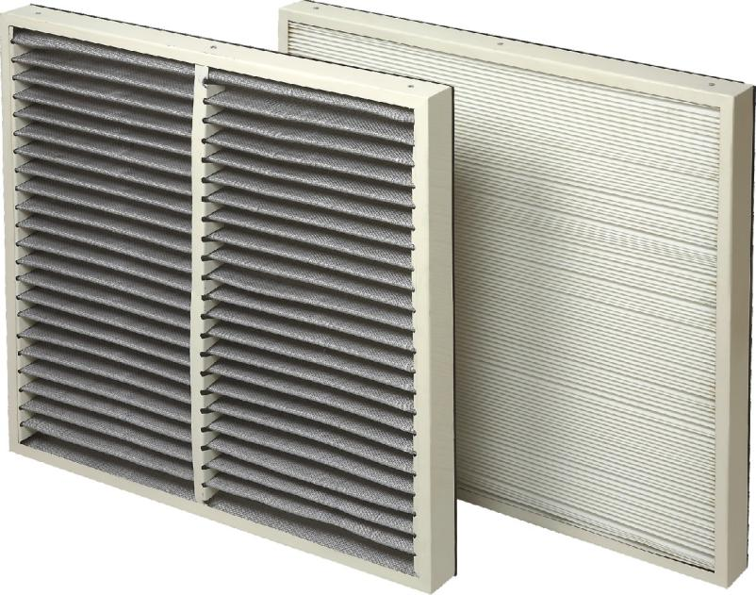

INTRODUCTION:

Panel filters are used in industries to retain particles ranging from 1 micron to 50 micron. These filters are basically air intake filters, which work with negative pressure of systems. These filters are further classified as.

Secondary filters are used for fine filtration for removal of particles in the range of 1 to 10 microns. Secondary filters are made from selective fiber media for better efficiency.

FEATURES AND BENEFITS:

•Low pressure drop due to pleated configuration

• Easy to install

• No bypassing

• Washable & reusable

• Highdirt holding capacity

• Good mechanical strength

• Retrofit to any standard make

Technical Specifications:

Configuration

• Flange type

• Box type

Sizes available

• 610mmx 610mmx 50mm/ 100mm/ 150mm/ 300mm

• 545mmx 545mmx 50mm/ 100mm/ 150mm/ 300mm

• Customized sizes are available on request

Filtration Rating

• 1, 3, 5, 10 microns & more

Filtration efficiency

• 80 – 90%

Frame Material

• SS 304 / GI (Galvanized Steel) / Aluminium Powder coated /CRC powder coated or Zinc coated

Filter media

• HDPE Media / Synthetic Fiber Media / Spun bonded polyester media