SS CARTRIDGE FILTER HOUSING

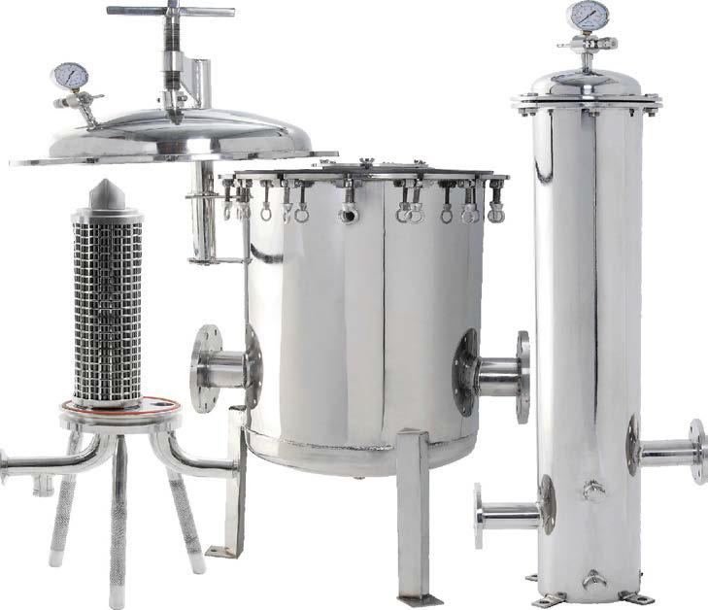

INTRODUCTION:

Cartridge filter system offers wide range of flow capacities & contaminant holding capacities. Cartridge filter housing diameters can accommodate around 1 to 500 cartridges. Cartridge filters are normally used as polishing filter in almost all process industries.Cartridgefilter is constructedof filterhousing, filter cartridges, tubesheet, positivesealingarrangement for cartridge depending upontype of cartridge&choice ofend connections.Positive sealing arrangement for cartridge filter assuresnoparticlemigrationorfibermigration,evenafter highdifferentialpressures.

Contaminated fluid enters the housing and is distributed evenly around the filter cartridges. Filtration takes place from outside to inside. Solids are collected on the outside of filter cartridges & clear filtrate is collected at outlet.

**Features & Benefits :**

• Low pressure drop

• High dirt holding capacity

• Zero hold up design

• Permanently piped housing are opened without special tools and without disturbing the piping

• Machined cover gasket groove provide positive O-Ring sealing

• Easy to clean

• In-line inlet and outlet high flow rates

• Positive sealing arrangement to avoid bypassing

• Suitable for double open end (DOE), Code 7 (226 O-Ring) & 222 O-Ring type filter cartridge

• Accommodates 10", 20", 30", 40", 50” & 60” long filter cartridges.

• End connections of ¾" to 24" pipe

• V posts or threaded center posts

• Quick opening tri clovers design

• Easy to operate & low maintenance

• Low down time

• Flow rate up to 2000 m3/hr & more

• Customized design available

• Housings are permanently piped

• All housings made from SS 316 L, SS 316 & SS 304 are mirror polished & electro polished to resist adhesion of dirt and scale

• Carbon steel housings are sand blasted, epoxy coated & finally painted with two coats of synthetic enamel

• Duplex / Triplex / Jacketed cartridge filter unit designs are available

•High temperature & high pressure designs are available

**Special Options:**

• High pressure rating

• Housings of alloy steel

• Steam jackets

• Special outlet locations

• Optional cartridge sealingmethods for 226, NPT, etc.

• High temperature gasket designs

**Technical Specifications:**

Sizes (Cartridge filter housings suitable for)

• 1 No. To 500 Nos. Of Cartridges in Single Housing

• 2”, 2.5”, 4”, 6” & 8” Diameter of Cartridge

• 10”, 20”, 30”, 40”, 50” & 60” Length of cartridge

Flow Rate

• Capacity: Up to 2000 m3/hr & more

Material of Construction

• SS316L •SS316 •SS304 •CARBONSTEEL(ALL GRADE)•MILDSTEEL•ALLOYMETALS

• Super Duplex, Duplex stainless steel 2205

• POLYPROPYLENE

Cartridge filter housing suitable for filter cartridges of

• Double Open End (DOE) Type

• Code 7 (226 O Ring) Design

• NPT Threaded Connection Type

Gasket / O Ring Material

• Neoprene • SpiralWound

• Nitrile •CAF

• Silicone

• Viton

• Buna N

• EPDM

• PTFE

• Spiral wound

• CAF

End connections available

• NPT / BSP Threaded

• Flanged End

• DIN Standard

• Tri Clover Adaptors

•

Applications:

|  |  |
| --- | --- |
| • Pharmaceuticals | • Petroleum Derivatives |
| • Water Treatment | • Coolants |
| • Paints & Inks | • Food & Beverages |
| • BoreWell water | • Dairy |
| • Dyes & Intermediates | • RO Pre filtration |
| • Processing Chemicals | • & Many More |